REQUIREMENTS FOR PUBLICATIONS

Texts of scientific articles of 6–15 pages should be typed in a Word text editor: DOC format, TimesNewRoman font, 12 pt font size, single spacing, all fields - 2 cm, indention at the beginning of the paragraph -1.25 cm.
On the first line (1st line) the UDC index is written in the left corner. Through the line (3rd line) in the right corner of the full name. author completely. On the following lines - the name of the organization (4th line), city, country (5th line) and the author's email address (6th line). Through the line in the center (8th line) - the name of the article in capital letters in bold in Kazakh, Russian and English. The main text begins in one line.

Annotation and keywords are written in Kazakh, Russian and English. Recommended average annotation volume is 50 words. References to sources of literature should begin with the number [1] and be placed consistently in the text of the article as far as the source is mentioned in the original language. Placing in the list of references a source to which there is no reference in the text of the article is unacceptable.
Graphic material

Graphic material should be located immediately after the text in which they are mentioned for the first time. The graphic material is numbered in Arabic numerals (for example: Figure 1). The caption to it is located under it in the middle of the line. Any graphic material (drawing, diagram, chart, drawing, etc.) is designated by the word Picture. The word "Figure" is written completely. Images used in the article should be in jpg format.
Tables
The table should be located immediately after the text in which it is mentioned for the first time. All tables are numbered (for example: Table 1). The word "Table" is spelled completely. The name of the table should be placed above the table on the left, without indention in one line with its number after a dash (for example: Table 3 - Incomes of the company). There is no dot at the end of the name.
Formulas
Formulas and equations should be separated from the text on a separate line. Above and below each formula or equation must be left on an empty line. If the equation does not fit in one line, then it should be moved after the equals sign (=) or after the plus signs (+), minus (-), multiplication (x), division (:), or other mathematical signs, and this sign at the beginning of the next line is not repeated. If explanations of symbols and coefficients are needed, they are given immediately below the formula in the same sequence in which they appear in the formula. Formulas are numbered. The number is stamped in Arabic numerals in parentheses in the extreme right position on the line. If necessary, explanations to the coefficients and symbols are given under the formula immediately, observing a sequence that reflects their appearance in the formula, and the beginning of the first line of explanation should be the word "where".
In case of non-compliance with the requirements, the article may be sent to the authors for revision or rejected both on technical and scientific grounds. It is not allowed to send to the editors of papers that are published and / or accepted for publication in other editions.
SAMPLE OF ARTICLES (in Russian)
UDC 539.42

Sadykov Marat Erlanovich
Ph.D., Associate Professor of the Department "Economics and Innovative Business"
University "Turan-Astana",
Astana, Republic of Kazakhstan
E-mail:
ЭКОНОМИКАЛЫҚ ДАМУДЫҢ ФАКТОРЛАРЫ
ФАКТОРЫ ЭКОНОМИЧЕСКОГО РОСТА
FACTORS OF ECONOMIC GROWTH

Аннотация. Мақалада экономикалық өсу мәселесі талқыланды.
Түйінді сөздер: экономика; көші-қон

Аннотация. В статье рассмотрена проблема экономического роста в Республике Казахстан. …
Ключевые слова: экономический рост; миграция

Annotation. The article considers the problem of economic growth in Kazakhstan.…
Keywords: economic growth; migration

Due to the difficulties of measuring the process of economic development in macroeconomics, economic growth is analyzed most often, but this is only one of the indicators of the process of economic development, although it is leading [1,25].

F=m x a, (1)

where F – resultant of all forces;
m – body mass;
a - acceleration

Table 1 - Table Name

Text | Text | Text | Text
Text | Text | Text | Text
Text | Text | Text | Text

Text. Text. Text. Text. Text.

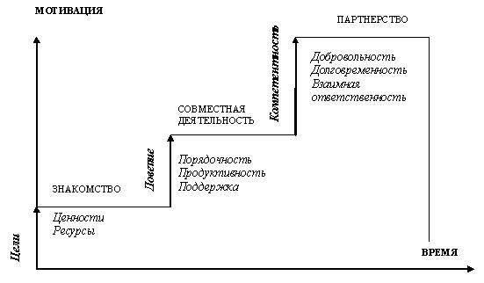
Figure 1 - Name of the picture

Literature:
1 Kuchukova N.K. Macroeconomic aspects of reforming the financial and credit system over the years of independence of Kazakhstan: background, trends and development prospects: monograph. Astana: KazUEFiMT, 2011. P.310
2 Nureev R.M. Factors of economic development of Kazakhstan. Bulletin KazEU.– Almaty: “Economy”, 2009. – №6. –S.25–30.

